Lab 12 - Postgresql

Neven Said
Lab exercise 1 (Tuesday, April 29)
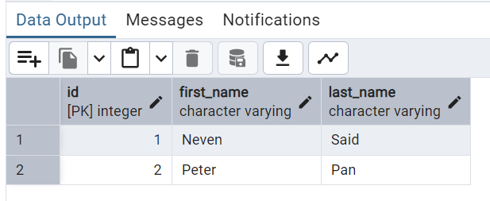

Table Courses
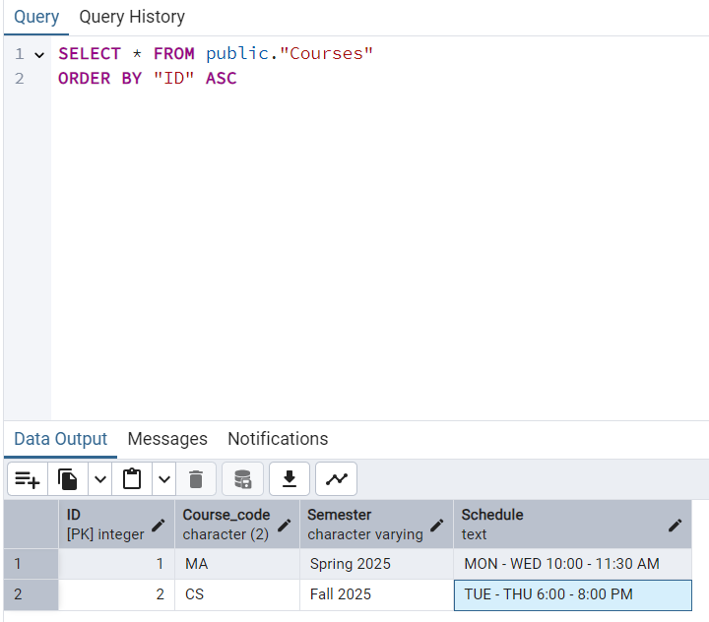

Table Tuition
